Client Representative (CR) - Delos Reyes, Gaius Vincent
Project Manager (PM) - Grande, Mico
Business Analyst (BA)-Bujawe, Marc Reil
Lead Developer (LD)- Fuentes, Jay
UI/UX Designer (UX) - Sariol, Jama Paolo
Quality Assurance Lead (QA) - Malda, Aaron Jan Raf
Finance Officer (FO)-Banaag, Yuri
Operations Manager (OM)- Baldonado, Prince Audi
Customer Support Lead (CS) - Jaraplasan, Dan Gabriel
GROUP REFLECTION
Our team meeting was carefully planned with a clear agenda and defined roles to ensure that all aspects of the Campus Event Management System were discussed efficiently. The Project Manager set the tone by outlining objectives, while each member, from the Business Analyst to the Customer Support Lead, contributed their perspective. Preparation involved reviewing client requirements, anticipating potential technical issues, and drafting questions to clarify expectations.

During the meeting, we encountered challenges such as managing time effectively while allowing everyone to voice concerns and ensuring that technical discussions remained understandable for non-technical participants. Additionally, coordinating different schedules for all team members highlighted the difficulty of maintaining full attendance in online settings.

Through this process, we learned the importance of structured online collaboration. Clear communication, active listening, and visual aids such as shared screens or slides helped bridge gaps that naturally occur in virtual meetings. Assigning roles and following a defined sequence of discussion ensured that decisions were documented and responsibilities were clear. Overall, the meeting strengthened our understanding of effective teamwork in a remote environment, emphasizing planning, adaptability, and inclusive participation.
YT LINK:https://www.youtube.com/watch?v=hKbh4eAi-Lk

EMAIL:

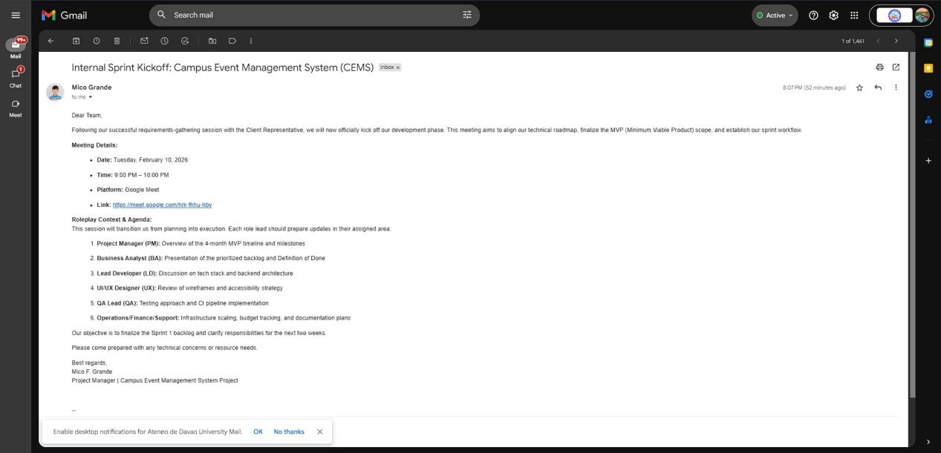

Google Meet:

